File-Based DBMS

🗃️ What Are File-Based Databases?
# Source: AI Source: Provided by: [Data Path: Persons Table -> ID Column: 1, Name_En Column: Motasem Essam] -> From: [ChatGPT] on [6/10/2026]
A file-based database stores all data in a single file or a small set of files on the file system.
There is no separate database server process — the application directly reads and writes to the file.
✅ It’s like having a self-contained database built into your app.

🔍 Key Features of File-Based DBs
# Source: AI Source: Provided by: [Data Path: Persons Table -> ID Column: 1, Name_En Column: Motasem Essam] -> From: [ChatGPT] on [6/10/2026]

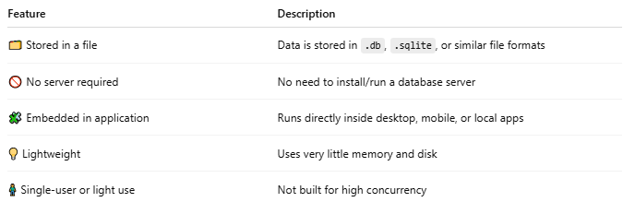
Feature | Description
🗂 Stored in a file | Data is stored in .db, .sqlite, or similar file formats
🚫 No server required | No need to install/run a database server
🧩 Embedded in application | Runs directly inside desktop, mobile, or local apps
💡 Lightweight | Uses very little memory and disk
🧍 Single-user or light use | Not built for high concurrency

✅ Examples of File-Based DBs
# Source: AI Source: Provided by: [Data Path: Persons Table -> ID Column: 1, Name_En Column: Motasem Essam] -> From: [ChatGPT] on [6/10/2026]
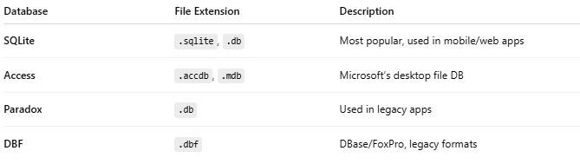
Database | File Extension | Description
SQLite | .sqlite, .db | Most popular, used in mobile/web apps
Access | .accdb, .mdb | Microsoft’s desktop file DB
Paradox | .db | Used in legacy apps
DBF | .dbf | DBase/FoxPro, legacy formats

🆚 File-Based vs Client/Server DB
# Source: AI Source: Provided by: [Data Path: Persons Table -> ID Column: 1, Name_En Column: Motasem Essam] -> From: [ChatGPT] on [6/10/2026]
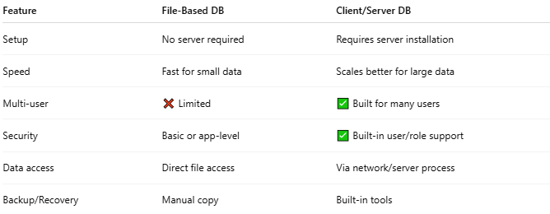
Feature | File-Based DB | Client/Server DB
Setup | No server required | Requires server installation
Speed | Fast for small data | Scales better for large data
Multi-user | ❌ Limited | ✅ Built for many users
Security | Basic or app-level | ✅ Built-in user/role support
Data access | Direct file access | Via network/server process
Backup/Recovery | Manual copy | Built-in tools

📱 Where File-Based DBs Are Used
# Source: AI Source: Provided by: [Data Path: Persons Table -> ID Column: 1, Name_En Column: Motasem Essam] -> From: [ChatGPT] on [6/10/2026]
- Mobile apps (e.g., Android uses SQLite)
- Desktop apps (e.g., small business tools)
- Testing and prototyping
- Embedded systems (IoT devices, browsers)

🧪 Example: Using SQLite
# Source: AI Source: Provided by: [Data Path: Persons Table -> ID Column: 1, Name_En Column: Motasem Essam] -> From: [ChatGPT] on [6/10/2026]
A file-based SQLite DB stores data in one file like mydata.db. You can query it directly:
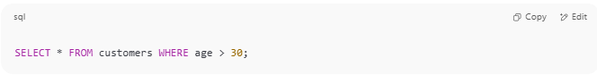
SELECT * FROM customers WHERE age > 30;

No need for a server like SQL Server or MySQL — your app reads that file directly.

✅ Summary
# Source: AI Source: Provided by: [Data Path: Persons Table -> ID Column: 1, Name_En Column: Motasem Essam] -> From: [ChatGPT] on [6/10/2026]
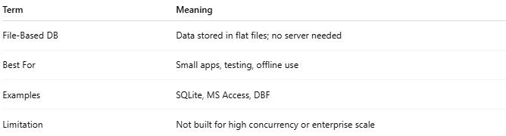
Term | Meaning
File-Based DB | Data stored in flat files; no server needed
Best For | Small apps, testing, offline use
Examples | SQLite, MS Access, DBF
Limitation | Not built for high concurrency or enterprise scale

